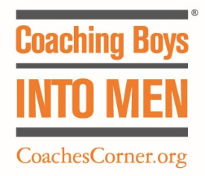

Parents and Guardians,
I am informing you of a program that I will be teaching to the team over the course of the season. The Program is called Coaching Boys Into Men (CBIM).
CBIM is a program that aims to use the coach as a mentor in teaching young student athletes about responsibility and respect for others, especially towards women and girls. (Name of School) has chosen to participate in CBIM. I will be discussing 12 different topics with the team such as personal responsibility, insulting language, disrespectful behavior towards women and girls, when aggression crosses the line, and digital disrespect.
Participation in CBIM discussions requires a pre and post survey that will be used to measure the program’s effectiveness in Sonoma County. If you wish to excuse your son from participating in CBIM team discussions and surveys, please sign below and return to the school office.
Please go to www.CoachesCorner.org to learn more about CBIM or contact me: (enter contact info here). If you have any questions or concerns about CBIM, please let me know. CBIM will be a beneficial learning experience for your child and I thank you for your time in reading this letter.

I want my child to be excused from CBIM discussions and surveys:
Parent Signature Date

